TUGAS QUERY INDEX

NAMA : MAHA DIVTA SEMBIRING

KELAS : TRPL-5C

NIM : 2205181051

MAPEL : MANAJEMEN BASIS DATA CLIENT SERVER

1. QUERY INDEX CHECK OUT RESERVASIONS

HASIL EXPLAIN SEBELUM INDEXING:

“EXPLAIN SELECT * FROM reservations WHERE check_in >= '2024-01-01';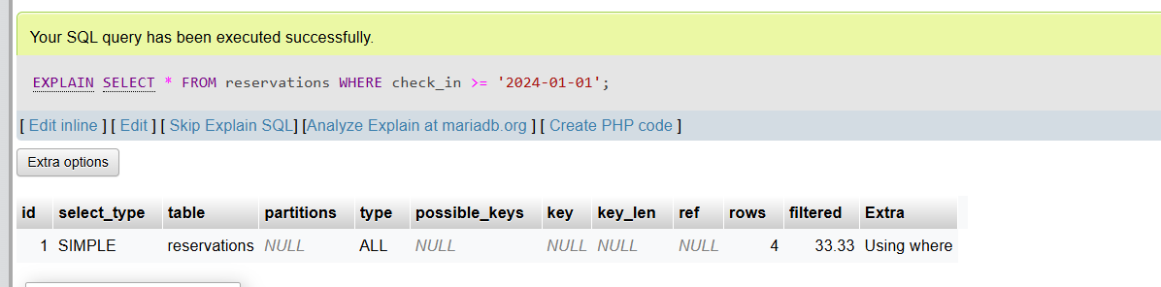

SETELAH DILAKUKAN INDEXING :

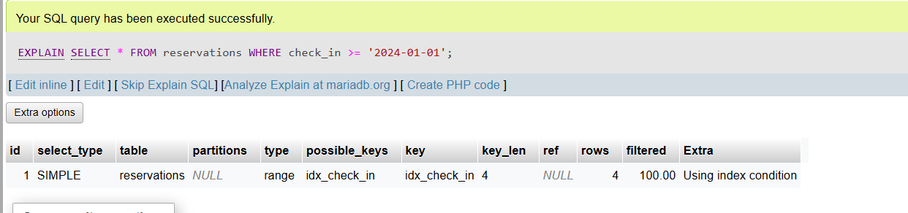

1. QUERY INDEX CUSTOMERS:

“ EXPLAIN SELECT * FROM customers WHERE name = 'Bob Brown';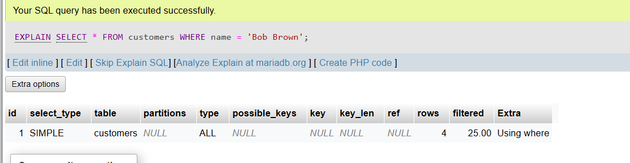 ”

PROSES INDEX:

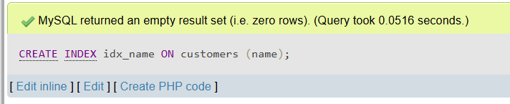

SETELAH DILAKUKAN INDEX:

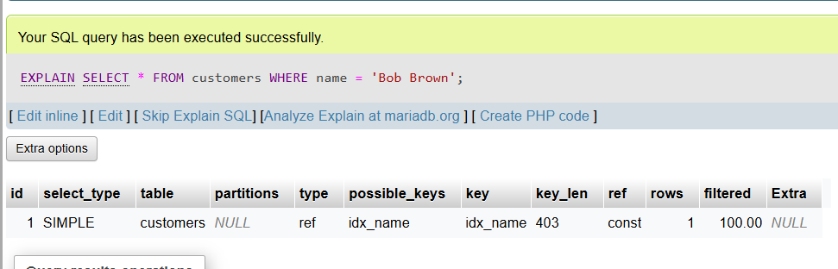

1. QUERY INDEX PAYMENTS:

“ EXPLAIN SELECT * FROM payments WHERE payment_date = '2024-11-03'; ”

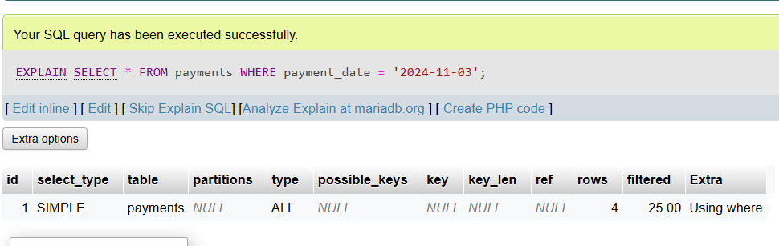

PROSES INDEX:

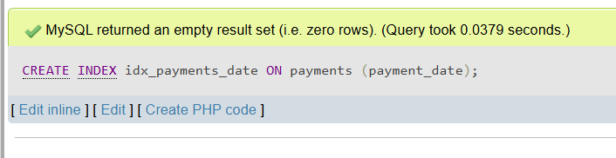

SETELAH DILAKUKAN INDEX:

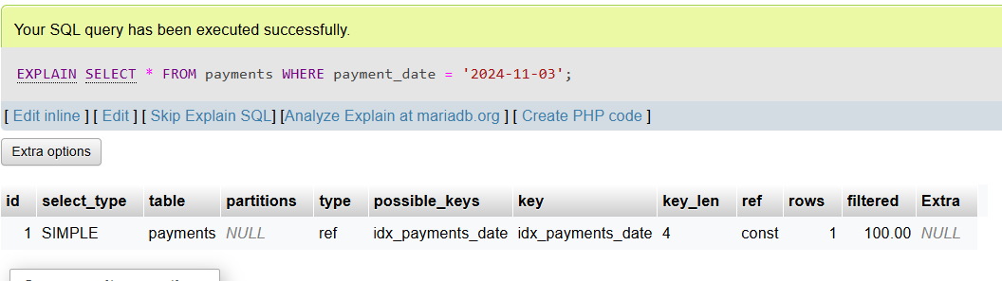

1. QUERY SEBELUM INDEX :

EXPLAIN SELECT * FROM rooms WHERE type = 'Single';

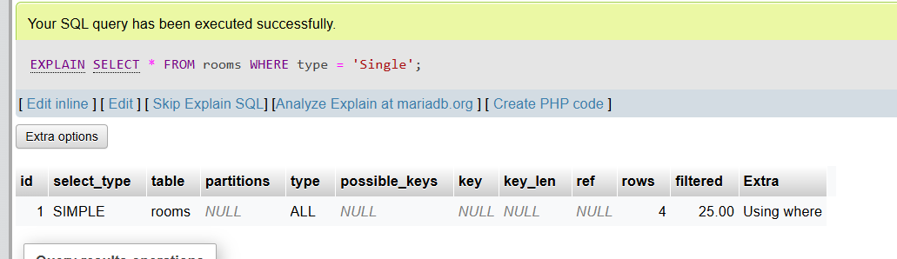

PROSES INDEX:

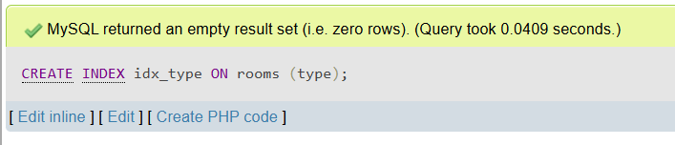

SETELAH DILAKUKAN INDEX:

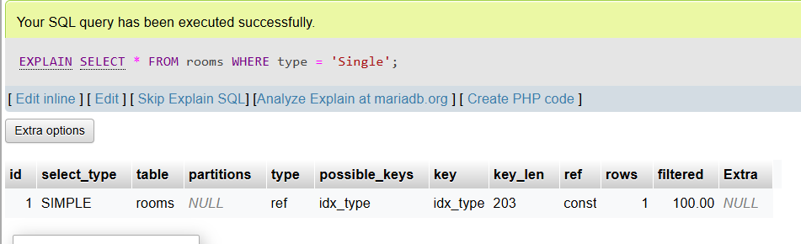

LINK DATABASE NYA :

<https://drive.google.com/drive/folders/1Cmw-elRCKBoDSCX3aBF2VVOWtn4O9ZZl?usp=drive_link>